**EXERCISES**

Complete the exercises assigned by your instructor. For Access databases, remember to name them using your last name, first name, lab #8, and the exercise number. Attach this document and your zipped databases to the Lab 8 Assignment in Brightspace and submit the assignment in Brightspace.

1. The tables shown below are two tables from a payroll system. The primary key fields in each table are marked with (PK). Using concepts presented in Lab 7, identify the design problems and draw a revised design that corrects those problems. Then create the revised tables in Access along with the necessary table relationships.

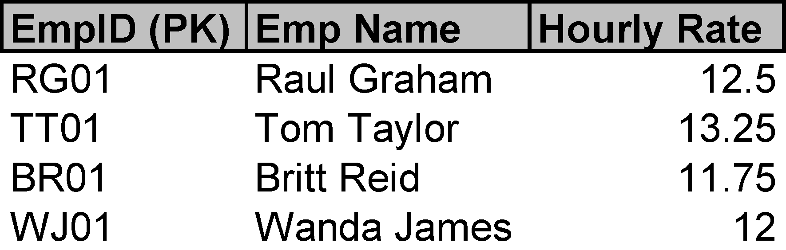

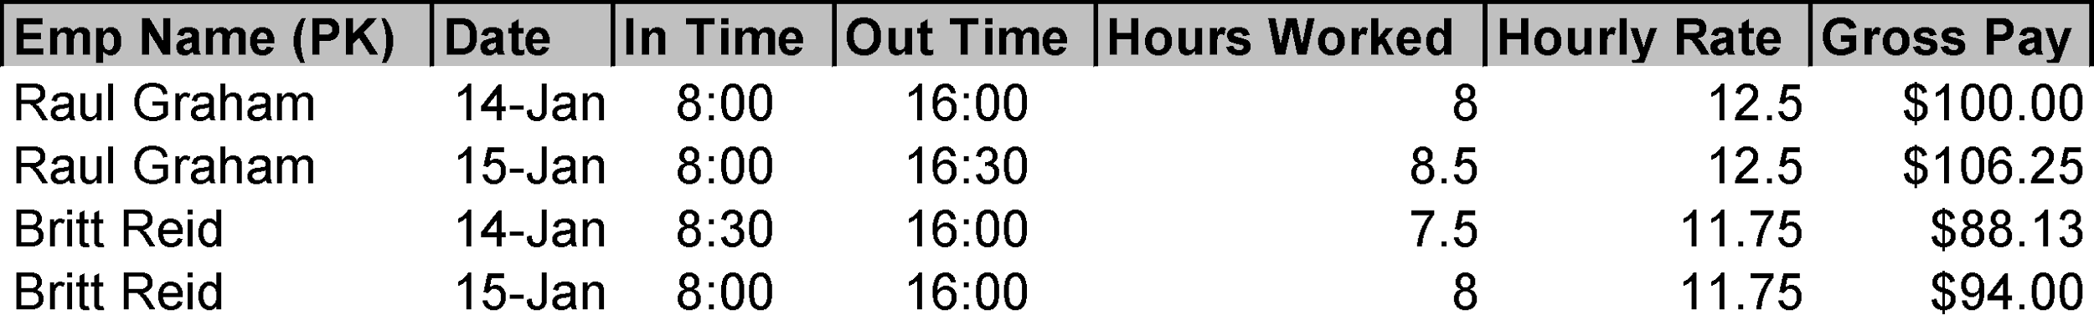

Design problems: The two tables contain redundant information in the Hourly Rate column; it is only needed in one table. Gross Pay is also not needed as it is just a calculation of the two existing columns Hours Worked and Hourly Rate. In the second table, Emp Name should not be used as the primary key as it does not contain unique values. EmpID would be a better fit to use as a foreign key to link the two tables.

| EmpID (PK) | Emp Name | Hourly Rate |
| --- | --- | --- |
| RG01 | Raul Graham | 12.5 |
| TT01 | Tom Taylor | 13.25 |
| BR01 | Britt Reid | 11.75 |
| WJ01 | Wanda James | 12 |

| EmpID (FK) | Emp Name | Date | In Time | Out Time | Hours Worked |
| --- | --- | --- | --- | --- | --- |
| RG01 | Raul Graham | 14-Jan | 8:00 | 16:00 | 8 |
| RG01 | Raul Graham | 15-Jan | 8:00 | 16:30 | 8.5 |
| BR01 | Britt Reid | 14-Jan | 8:30 | 16:00 | 7.5 |
| BR01 | Britt Reid | 15-Jan | 8:00 | 16:00 | 8 |

1. Implement an Access database with tables, fields, relationships, and indexes using the final version of the Library System discussed in Lab 8.